DUJIANGYAN OVERVIEW

Geographical location and other basic information:
Dujiangyan (都江堰) is a country level city located in the central part of Sichuan province in the People's Republic of China. It is situated along cost of Minjiang River. Dujiangyan is only 39 km away from Chengdu city, and 62 km away from Chengdu Shuangliu airport. When traveling from Chengdu to Dujiangyan, you can either take a 40 minutes ride by car down the Cheng-Guan highway or choose a direct, high speed train connection, brand-new expressway is also available. The city area covers 1208 km² and houses about 800 000 inhabitants. Climate of the area is classified as humid subtropical type. The weather is pleasant, with the annual average temperature of 15.2 °C, without extreme temperatures neither in winter, nor in summer. Water and air quality in the area meet national standards. The landform of Dujiangyan is mountainous, with mountains area covering around 60% of the territory.
Tourist attractions and historical sites
Dujiangyan Water Irrigation System
Dujiangyan Water Irrigation System is a famous piece of ancient technical heritage. It has been designed and built on Minjiang river in 3 century BC by a Qin state administrator- Li Bing. Back then ability to control natural elements, and guide course of the rivers was crucial in agriculture development. The Dujiangyan Irrigation System was constructed about the same time when the foundations for the Great Wall has been laid, but in contrary to the wall, irrigation system still fulfills the same function as 2,250 years ago. What is more, its work is much more efficient than in ancient times. Dujiangyan diverts river water to Chengdu Plain and sustains development of this territory.
Mountain Qingcheng
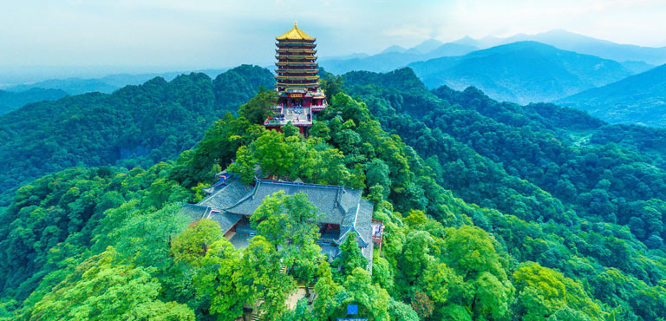
It is said that Dujiangyan is the cradle of Chinese Daoism, and Mountain Qingcheng is considered to be the birthplace of Chinese Daoism. It is also classified as one of four sacred Daoist peaks in China. Mountain Qingcheng was recognized outside China and was granted a title of UNESCO World Heritage Site. Here many Chinese come to pilgrimize and contemplate. But also many priests and monks live here. Generally the site is a afforested, nature-oriented area with Daoist and Buddhist temples. The most significant of them is Laojun Pavilion situated at the highest peak of the mountain range - Pengzu Peak, the building was built in praise of Laozi. Another important place of worship is Tianshi Cave, many people claim it is a place where Daoism originated from. This temple is managed by monks and offers accommodation and opportunity to observe daily life of monks and nuns, which can be a unique experience. Shangqing Palace is another key location in this area, it is a complex of wooden temples and halls. It offers breath-taking views of the valley.
City God Temple and Ten Dragons Hall
Ten Dragons Hall is a complex of halls, which has been built on both sides of steps leading to the City God Temple. The interior of the temple is rather dimly lit, what drives attention is a big, golden statue of City God located in the middle of the temple, and six accompanying, terrifying statues of Daoists immortals.

Giant Pandas
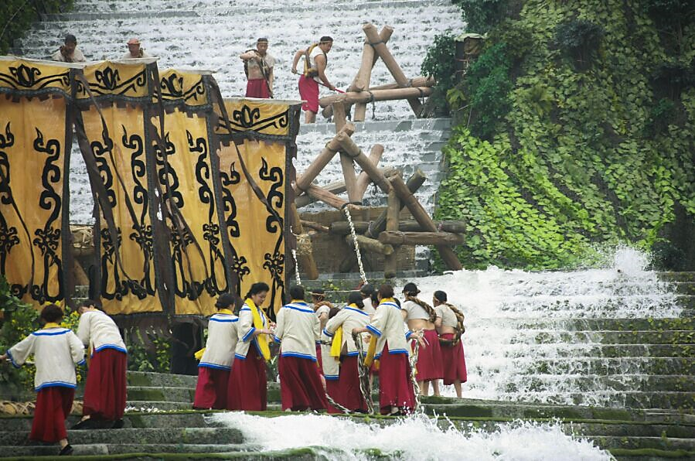
There are two Giant Panda centers next to Chengdu city, first one is The Wild-Release Base of Panda- Panda Valley, located in Yutang city, Dujiangyan. The total of the center area covers 1,336 km² and can accommodate 30-40 giant pandas and 50-100 and other species of wild animals such as lesser pandas, etc. The center was opened in order to help, giant pandas which live in captivity to learn how to survive in natural, wild, habitat, monitor the giant panda population and under supervision of experts expand it. Second place is Dujiangyan Base for China Giant Panda Protection Research Center in Shiqiao village, Qingchengshan Town. It is a good destination for pandas and nature lovers. The architecture of the center is inspired by western Sichuan style buildings. Here visitors can take part in volunteer programs as panda keepers.

Festivals and cultural events
Year after year many cultural events and festivals organized in Dujiangyan attract both tourists and locals. The most famous one is Water Releasing Festival held in April at the time of Qingmingjie- Pure Brightness Festival. Origin of Water Releasing Festival derives directly from citie's ancient, water irrigation tradition. In the past inhabitants of the area used to build cofferdams at Minjiang River and accumulate water, after it reached planned level, the barriers would be torn down and the river water released to irrigate fields before upcoming harvest season. For those who like to affirm the nature, annual Longchi Rhododendron Festival is recommended, it is the second largest garden of this kind in the world, with hundreds of plant species to see. Kiwifruit originates from China, and Dujiangyan territory is famous for cultivation of this plant. For this reason local Kiwifruit Festival is organized every year in mid- October, visitors can taste samples of the fruit, and all kinds of gourmet food produced from kiwifruit.

